**SUMMER TRAINING REPORT**

**SRI GURU TEGH BAHADUR INSTITUTE OF MANAGEMENT AND INFORMATION TECHNOLOGY**

**(2019-2022)**



**SUBMITTED TO :**

GURU GOBIND SINGH INDRAPRASTHA UNIVERSITY (GGSIPU)

**SUBMITTED BY :**

NITIKA RAWAT

ENROLL NO. 09590202019

BCA, 5TH SEM, 3RD YEAR.

**SUMMER TRAINING REPORT**

**SRI GURU TEGH BAHADUR INSTITUTE OF MANAGEMENT AND INFORMATION TECHNOLOGY**

**(2019-2022)**



**SUBMITTED TO :**

SRI GURU TEGH BAHADUR INSTITUTE OF MANAGEMENT AND INFORMATION TECHNOLOGY (SGTBIMIT)

**SUBMITTED BY :**

NITIKA RAWAT

ENROLL NO. 09590202019

BCA, 5TH SEM, 3RD YEAR.

**LETTER OF CONFIRMATION**

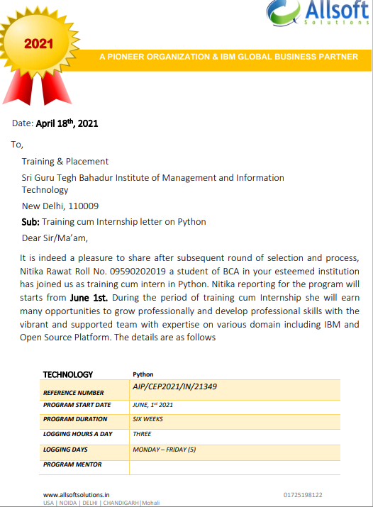

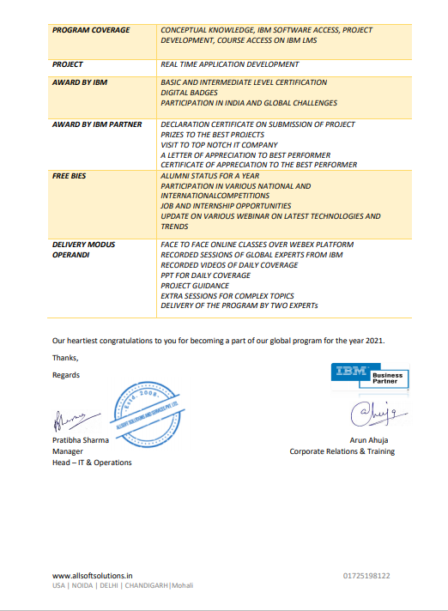

**LETTER OF COMPLETION**

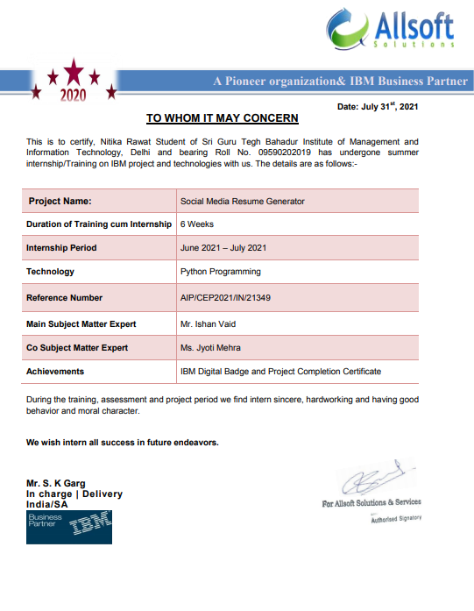

**PROJECT COMPLETION CERTIFICATE**

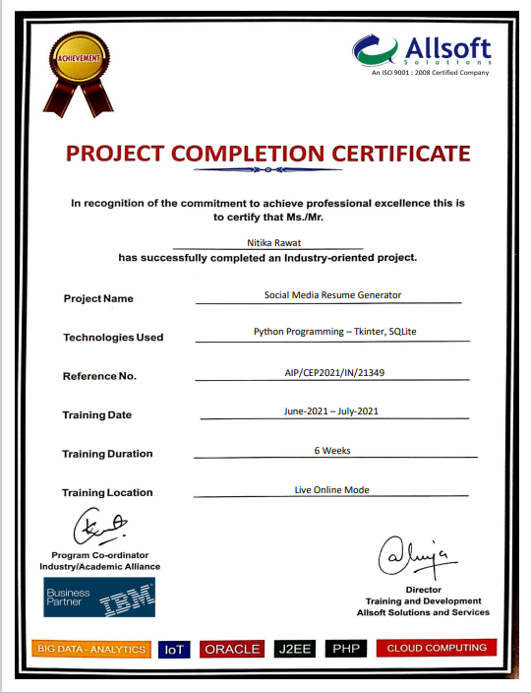

**ACKNOWLEDGEMENT**

I would like to express our heartfelt gratitude to **Sri Guru Tegh Bahadur Institute of Management & Information Technology** for giving us the opportunity to work under their guidance and help us gain immense professional experience. A sincere thanks to our mentor for giving us valuable inputs and ideas right from the selection of topic for project till its successful completion.

The successful completion of our project would not have been possible without the dedicated support from all our mentors, family, and friends.

**NITIKA RAWAT**

**09590202019**

**BCA, 5TH SEM, 3RD YEAR.**

**ABSTRACT**

In a world full of the internet, everyone is nowadays engaged socially

through many social media platforms. Be it be Facebook and

Instagram and so on. So we came up with the idea of creating a

project called **Social Media Resume Generator.**

Our project's main aim was to create the social media resume of the

user, which contains direct links to the profiles of the user, who is

active in some social media platforms.

Our project takes the user details and generates the resume. It

creates username key that is shared with people to invite them to

your social media platform.

This Python GUI-based project was created using the PyCharm IDE

platform. The GUI elements were designed using TKINTER python

and the back end was designed using PYTHON and SQLite.

**INTRODUCTION**

The proposed system is a User Interacting Platform System created using Python programming language is platform from where the users can connects and share their social information with others. Platform provides the idea of social life and links to social media accounts of the user i.e. major social media platforms in which user is active, they can connect with different type of people on different platform since each user shares the unique ID that we named Username.

This system provides communication so that users can share their thoughts without zero delay issues. This is small platform or application created using Python and its Modules which Generate resume compiling personal details and links to majorly used social media accounts . This platform helps you to with the people’s social life.

* ADVANTAGES FOR USERS:
* User can easily create the resume.
* Instead of mentioning and sharing username from different platform the person can share this resume.
* Thus, saves a lot of time.
* ADVANTAGES FOR ADMIN:
* Admin can manage all users.
* Admin can make any changes to the website.
* Admin can manage or modify the orders placed by the user.

**Tools and Platform**

* GUI used : Tkinter

**Tkinter** is the most commonly used library for developing GUI (Graphical User Interface) in **Python**. It is a standard **Python** interface to the Tk GUI toolkit shipped with **Python**.

* Programming Language used : Python

**Python** is a widely used general-purpose, high level programming language. With its emerging popularity python is become more common among developers and almost all new applications comprises of python since its easy to use deploy and manage.

* Database Connectivity : SQLite

SQLite is a software library that implements a self-contained, server less, zero-configuration, transactional SQL database engine. The source code for SQLite is in the public domain.

SQLite3 can be integrated with Python using sqlite3 module

**DB Browser** for **SQLite DB Browser** for **SQLite** is a free and open-source tool to interact with **SQLite** databases with a graphical interface. You can use the software to view and edit database files.

**System Requirement**

* Hardware requirements :

Processor : Intel(R) core(TM) i3 (recommended) and advance.

RAM : 2GB(minimum required) and advance.

Screen Resolution : 1600x900 recommended.

* Software requirements :

Operating System : 32 bit based OS (minimum required) and advance.

Windows 8 minimum required and advance.

Programming language : Python 3.8.10 preferred(Preinstalled).

Programming IDE : PyCharm IDE.

Python third party modules required : OpenCV, urllib3, Pillow.

**INDEX**

|  |  |  |
| --- | --- | --- |
| **SL NO.** | **TOPIC** | **PAGE NO.** |
| 1 | INTRODUCTION | 9 |
| 2 | USE CASE DIAGRAM | 12 |
| 3 | DFD LEVEL- 0 | 13 |
| 4 | DFD LEVEL - 1 | 14 |
| 5 | ER - DIAGRAM | 15 |
| 6 | SCREENSHOT/OUTPUT | 16 |
| 7 | CODING | 23 |
| 8 | CONCLUSION | 25 |
| 9 | Future Scope | 26 |

**USE CASE DIAGRAM**

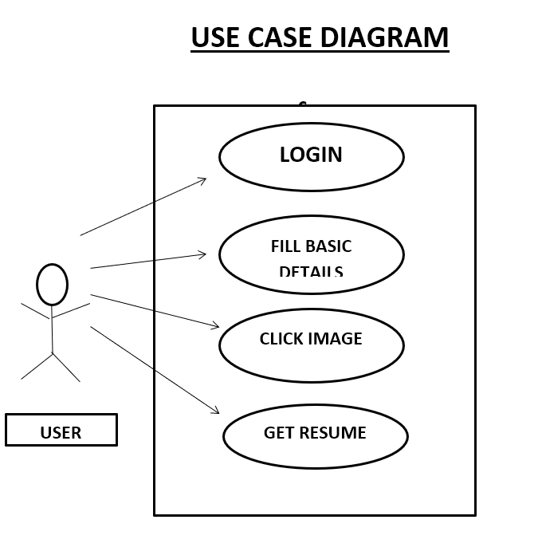

**DFD - LEVEL - 0**

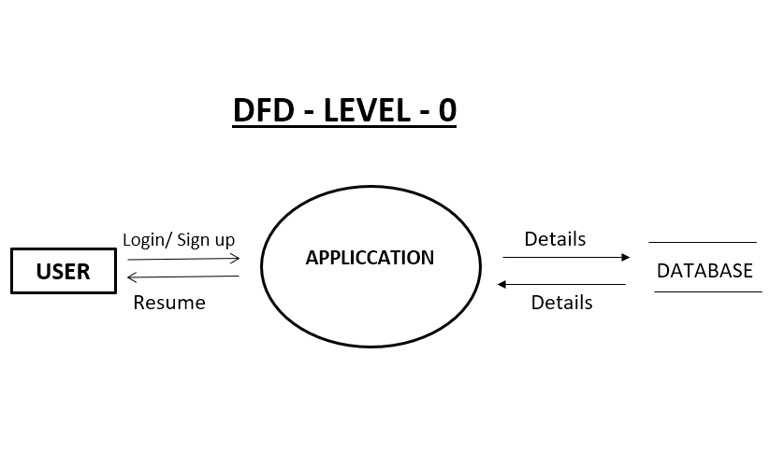

**DFD - LEVEL – 1**

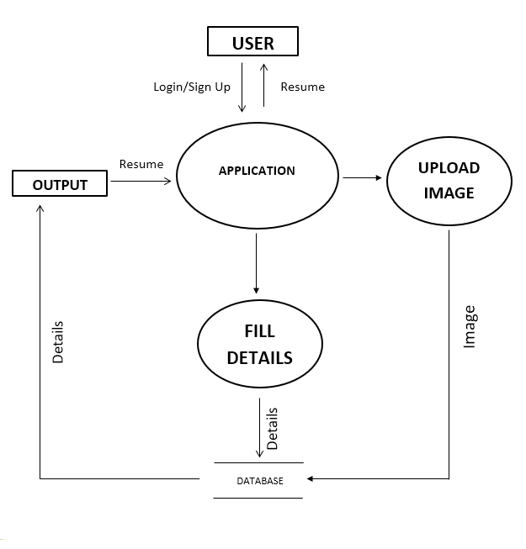

**E-R DIAGRAM**

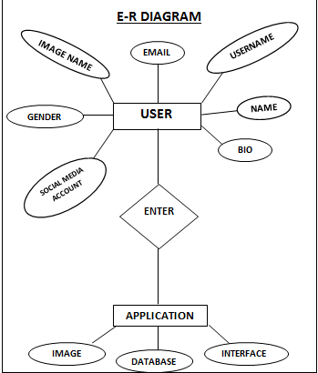

**SCREENSHOTS**

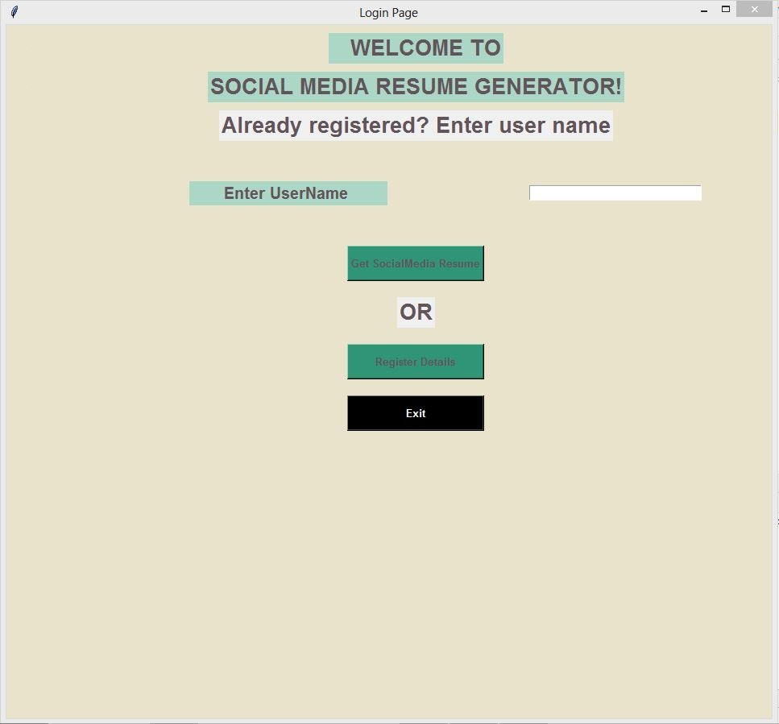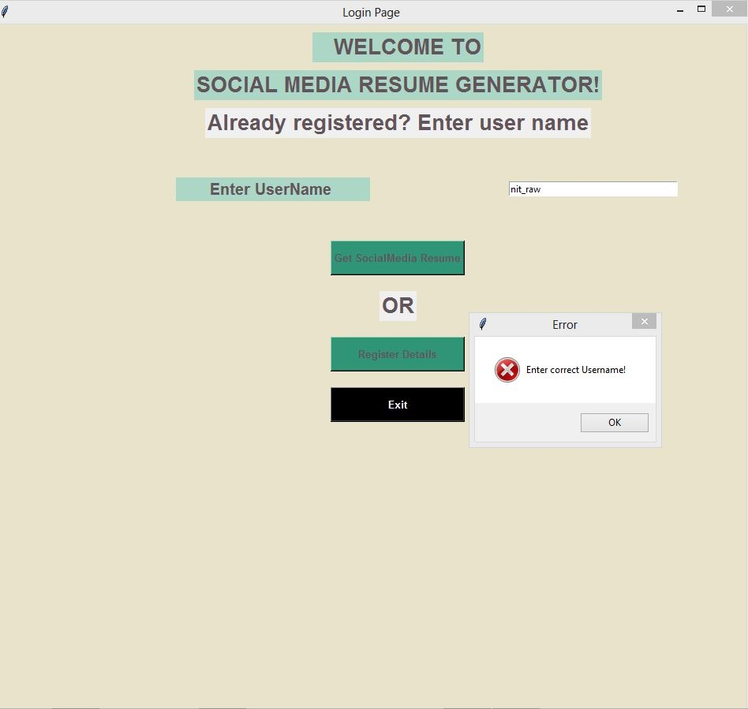

**LOGIN PAGE**

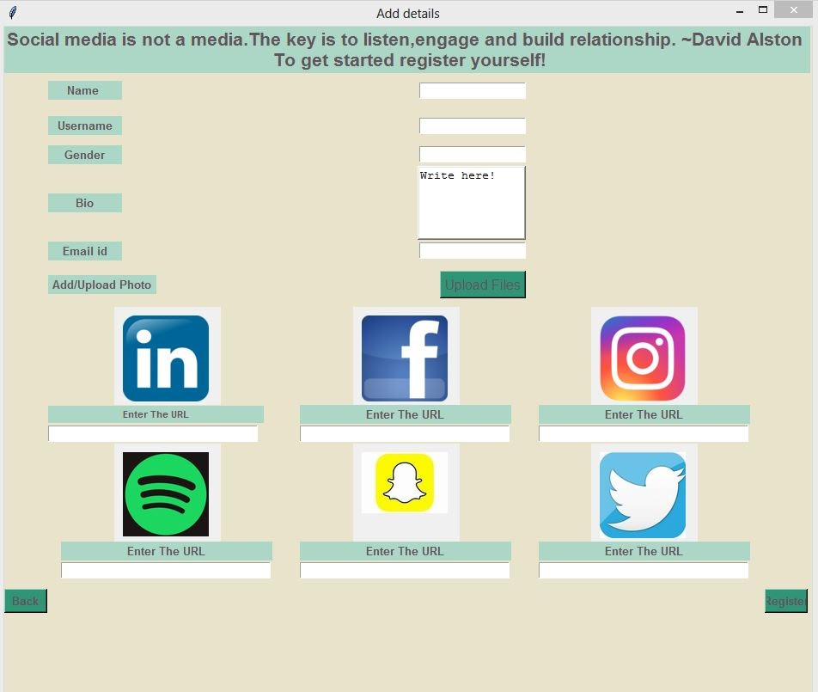

**Register Details page**

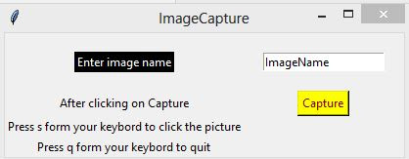

**Image name 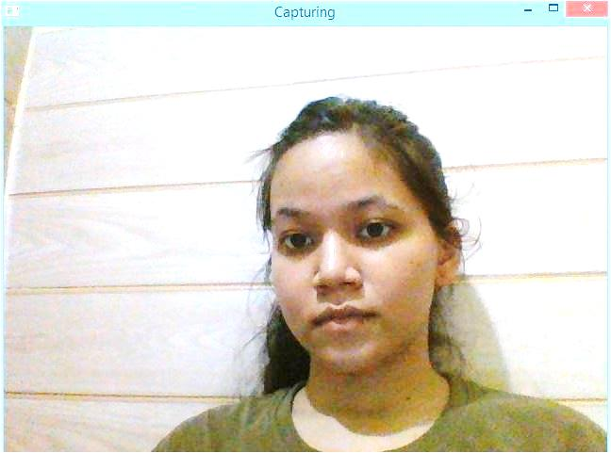Image capturing windows**



**Default Image(In case of no webcam)**

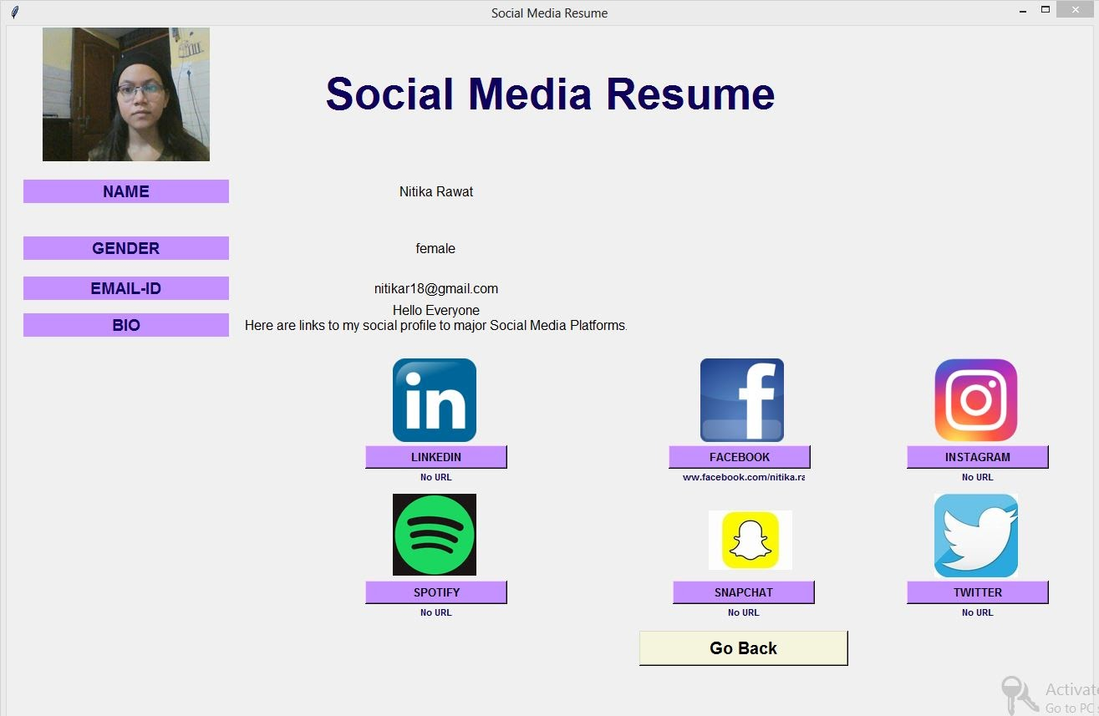   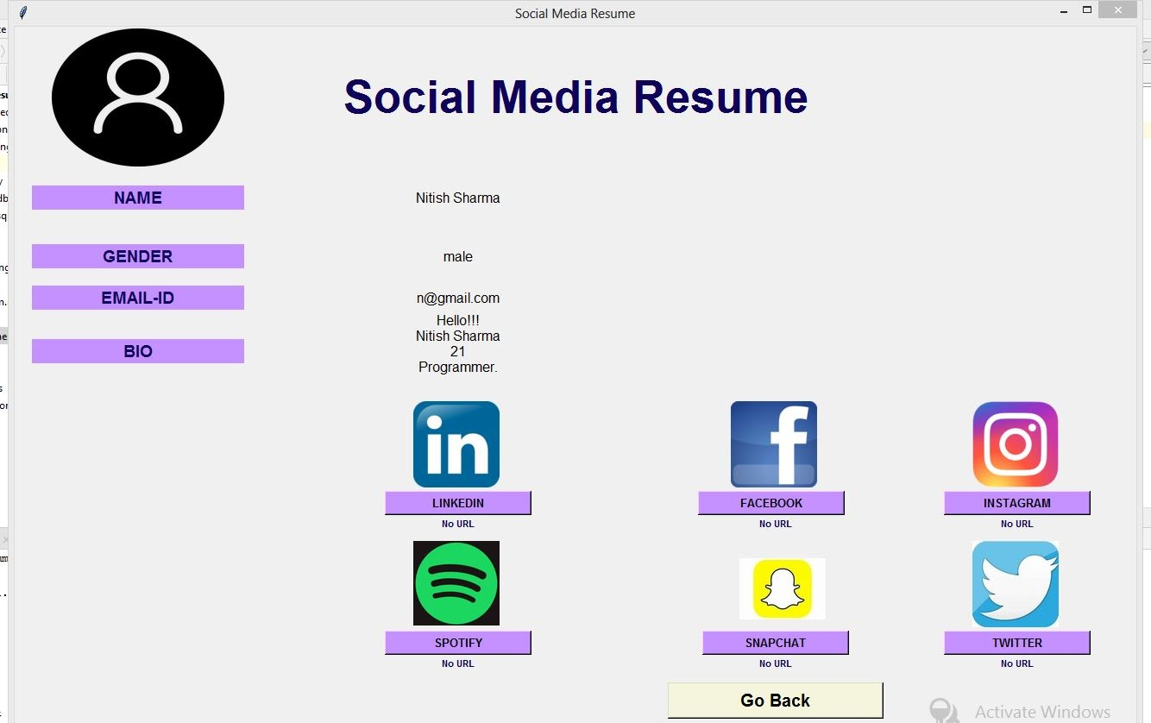

**Resume Generated (one with clicked image one with default image)**

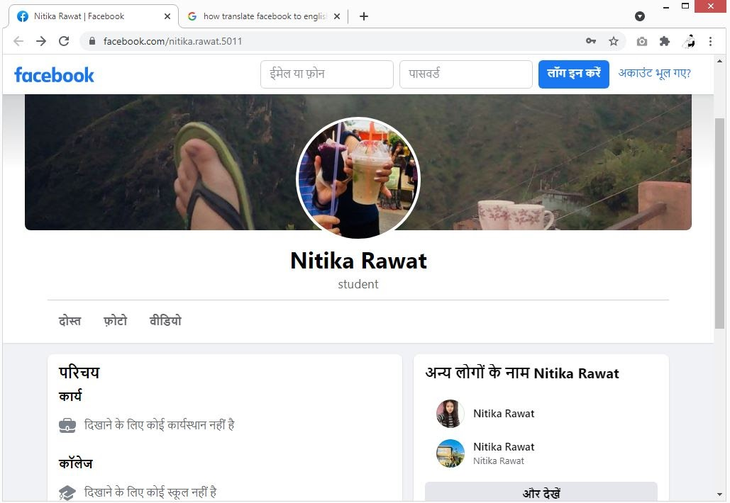

**When clicked on button of Facebook**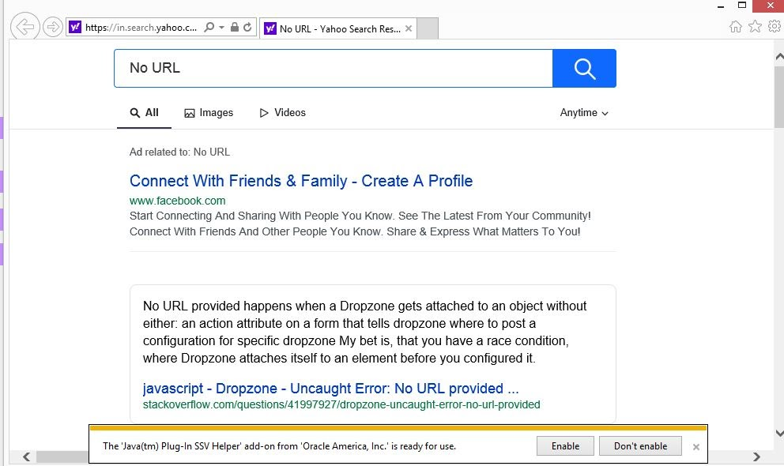

**When no URL given**

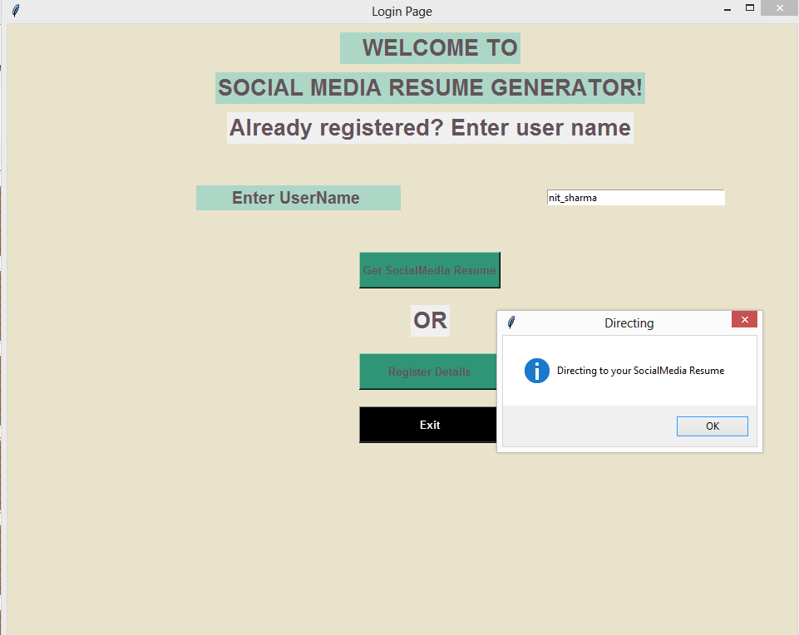



**Accessing resume directly through username**

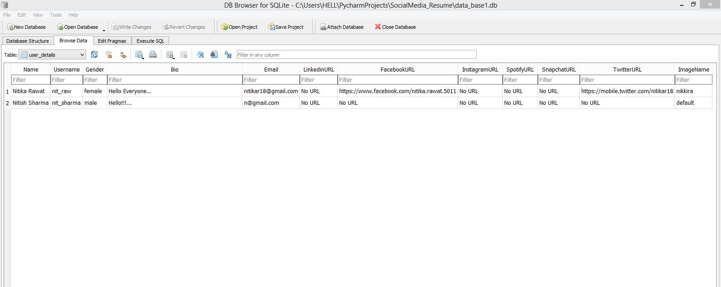

**Database Details**

**CODE DEMO**

**Filename** : 1main file.py

**import** form1 **as** f  
**if** __name__ ==**'__main__'**:  
 f.login()

**Filename** : form1.py

**from** tkinter **import** *  
**import** sqlite3  
**import** RegisterForm **as** R  
**import** SocialResumePage **as** S  
**from** tkinter **import** messagebox  
**def** login():  
 **def** exitprogram():  
 messagebox.showinfo(**"Exit"**,**'Exiting the Program'**)  
 login_screen.destroy()  
 **def** sigin_clicked():  
 login_screen.destroy()  
 R.register_function()  
 **def** login_clicked():  
 messagebox.showinfo(**"Directing"**, **"Directing to your SocialMedia Resume"**)  
 usernameValue =username.get()  
 **try**:  
 **try**:  
 conn = sqlite3.connect(**'data_base1.db'**)  
 cur = conn.cursor()  
 **except**:  
 cur.execute(**"CREATE TABLE user_details(Name VARCHAR(128), Username VARCHAR(128), Gender VARCHAR(128), Bio VARCHAR(128), Email VARCHAR(128), LinkedinURL VARCHAR(128),FacebookURL VARCHAR(128), InstagramURL VARCHAR(128), SpotifyURL VARCHAR(128),SnapchatURL VARCHAR(128), TwitterURL VARCHAR(128), ImageName VARCHAR(128)"**)  
 **finally**:  
 cur.execute(**f'SELECT Username FROM user_details WHERE Username="{**usernameValue**}"'**)  
 value1 = cur.fetchone()  
 userstr =value1[0]  
 print(**f"value from database {**userstr**}"**)  
 print(**f"value from tkinter entry {**usernameValue**}"**)  
 **if** (userstr == usernameValue):  
 login_screen.destroy()  
 S.resumepage(userstr)  
 **except**:  
 messagebox.showerror(**"Error"**, **'Enter correct Username!'**)  
 **finally**:  
 conn.commit()  
 conn.close()  
  
 login_screen= Tk()  
 login_screen.title(**"Login Page"**)  
 login_screen.geometry(**"950x950"**)  
 login_screen.config(bg=**'#EAE3CB'**)  
 f1=Frame(login_screen).grid()  
 f2=Frame(login_screen).grid()  
  
 l1=Label(f1,text=**" WELCOME TO"**, bg=**"#ACD7C6"**,fg=**'#63535B'**,font=**"TimesNewRoman 20 bold"**)  
 l1.grid(row=0, columnspan=5,padx=250,pady=10)  
  
 l2=Label(f1,text=**"SOCIAL MEDIA RESUME GENERATOR!"**, bg=**"#ACD7C6"**,fg=**'#63535B'**,font=**"TimesNewRoman 20 bold"**)  
 l2.grid(row=1, columnspan=5,padx=250)  
 lab = Label(f1, text=**"Enter UserName "**, width=20,bg=**"#ACD7C6"**,fg=**'#63535B'**,font=**"TimesNewRoman 15 bold"**)  
 lab.grid(row=5,column=1,padx=150,pady=40)  
 l1_2=Label(f1,text=**"Already registered? Enter user name"**,fg=**'#63535B'**,font=**"TimesNewRoman 20 bold"**)  
 l1_2.grid(row=4, columnspan=5,padx=150,pady=10)  
 *########get username#######3* username = Entry(f1,width=35)  
 username.grid(row=5,column=2,sticky=**"W"**)  
  
 *######login button######* loginbutton = Button(f2, text = **"Get SocialMedia Resume"**,height=2,width=20,bg=**"#2F9576"**, fg=**"#63535B"**,font=**"TimesNewRoman 10 bold"**,command=login_clicked)  
 loginbutton.grid(row=7, columnspan=20,padx=250,pady=10)  
  
 l1_2=Label(f1,text=**"OR"**,fg=**'#63535B'**,font=**"TimesNewRoman 20 bold"**)  
 l1_2.grid(row=8, columnspan=5,padx=150,pady=10)  
 *########Sigin button######* signin = Button(f2, text = **"Register Details"**,height=2,width=20,bg=**"#2F9576"**, fg=**"#63535B"**,font=**"TimesNewRoman 10 bold"**,command=sigin_clicked)  
 signin.grid(row=9, columnspan=20,padx=250,pady=10)  
  
 signin = Button(f2, text=**"Exit"**, height=2, width=20, bg=**"black"**, fg=**"white"**,font=**"TimesNewRoman 10 bold"**, command=exitprogram)  
 signin.grid(row=15, columnspan=20, padx=250, pady=10)  
  
 login_screen.mainloop()

**CONCLUSION**

In a nutshell, the project SOCIAL MEDIA RESUME GENERATOR helps users generate resumes of their social media life.

Here all the users can share their social resumes by sharing the username with new people they meet. Using that username person can go to that user's social media profiles of some major social media platforms and start following them.

In this project, we have used various python modules, libraries, and packages like Tkinter, Web-browser, sqlite3, cv2, PIL, util, etc.

In today's life people's interactions are everything and nowadays majorly interactions are made through social media platforms or any other online platform.

So, keeping in mind the importance of social media platforms in our user's life we tried creating our project SOCIAL MEDIA RESUME GENERATOR.

**FUTURE SCOPE**

* Web Based Application with more interactive UI and UX.
* Resume download option.
* Resume shareable link.
* User ID/ Username and Password login.
* Resume appreciation / Like Button.
* More security and assurance.